CSE3112: Software Development Lab.

Project Title: Software Requirements Specification (SRS) for Super Market Management System.

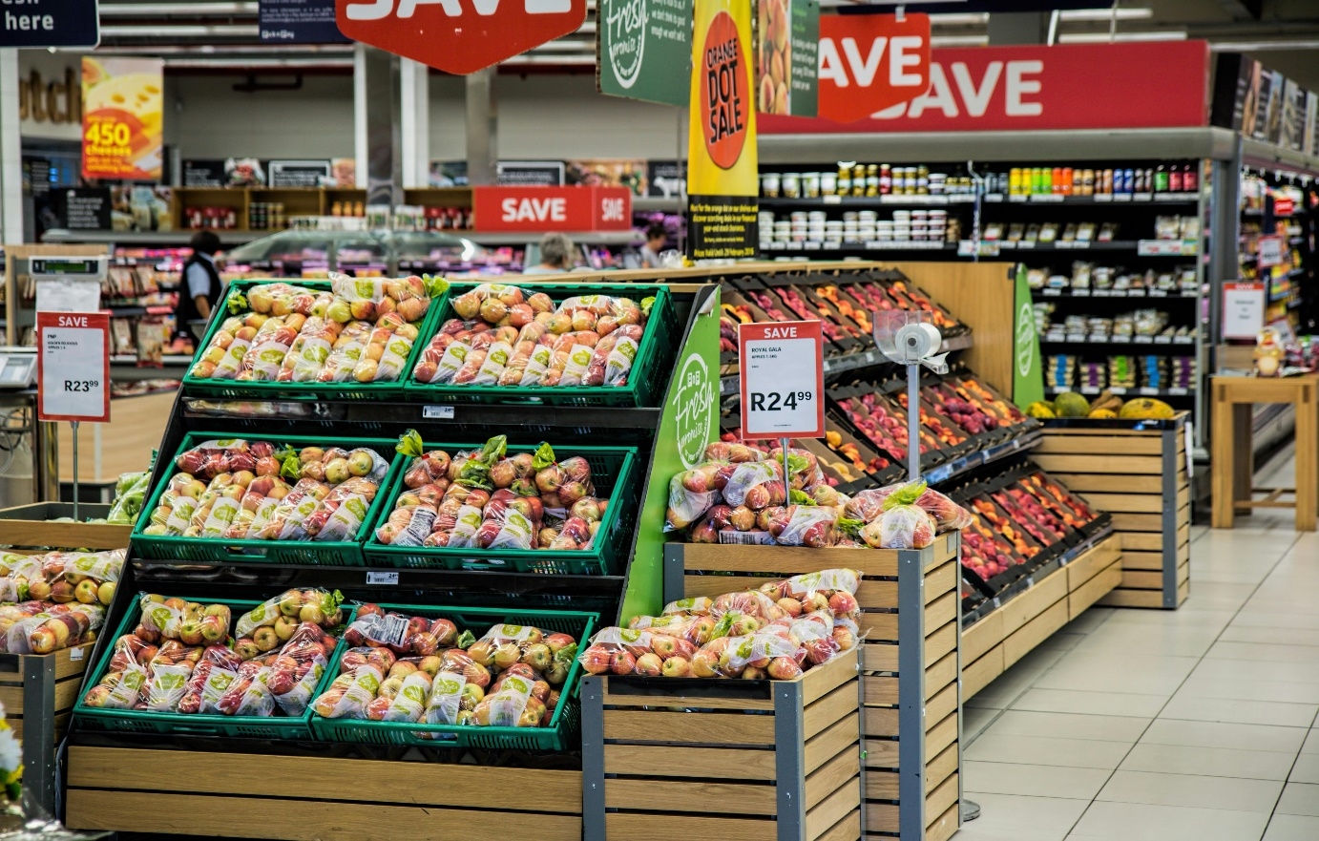

Prepared by,

Name: Syed Maksudul Arafin Dowan.

Roll: 213782101.

Semester: Part-3 (Odd)

Session: 2020-2021.

TMSS Engineering College,

Rangpur Road, Bogura.

Contents

**Chapter 1: Introduction** 2

1.1 Purpose 3

1.2 Project Scope 3

1.3 References 3

# **Chapter 1: Introduction**

## Purpose

This SRS describes the system functional and non-functional requirements for the first stable version intended for deployment of the supermarket management system. The primary goal of this system is to automate both the billing and inventory management processes within a supermarket environment.

In this document, all specified requirements are considered high priority and are committed for implementation in the first release. This means that each requirement is crucial for the system’s basic functionality and overall success.

## Project Scope

We can:

Manage users and full application.

Manage store details.

Manage customer details.

Manage sales report and calculate net profit.

Manage product details.

Create bills for customer.

Provide payment gateway for payment through different modes (cash, credit, and debit).

Allow user to view product from system.

We can’t:

Calculate salaries of employees.

Calculate the expenses on the product.

## References

* Supermarket customer routes-and-times identifiers in National University of Colombia, 2012.
* Supermarket Management System COMSATS University Islamabad, Wah Campus.
* [www.wikipedia.com](http://www.wikipedia.com)
* [www.chatgpt.com](http://www.chatgpt.com)

# **Overall Description**

## Product Perspective

The project is on Supermarket Management. Supermarket is the place where customers come to purchase their daily use products and pay for that. So, there is a need to calculate how many products are sold and to generate the bill for the customer.

Making software fast in processing, with good user interface so that user can change it, and it should be used for a long time without error and maintenance. To reduce the bottlenecks of the existing system there is a need to develop a new system. The new system should concern the requirements of the customer and the sellers. It has the following qualities:

1. Reduction in processing costs.

2. Error reduction.

3. Improve reporting.

4. Automatic production of the documents and Reports.

5. Faster response time.

6. Ability to meet user requirements.

7. Flexibility.

8. Reduced dependency.

9. Improves resource uses.

10.Reduction in use of paper.

11. Reduction in Manpower.

### System Interface